Engineers Without Borders
Mississippi State University Chapter

Thanks for your interest in joining the MSU chapter of Engineers Without Borders. As a student chapter, our organization and associated programs are driven by the devotion and efforts of a diverse group of students with skills and interests that extend far beyond engineering, so don’t stop reading if you’re not an engineer or even a scientist. We need people of all backgrounds, majors, and interests!!! Paramount to your success and that of the chapter is the transmission of knowledge, resources, and structure from one generation to the next. This short document will provide you with a basic outline of our mission, who we are as a chapter, and where you can go next to learn more about EWB-USA as well as our chapter’s work, both domestically and abroad.

What is EWB-USA?

Engineers Without Borders USA builds a better world through engineering projects that empower communities to meet their basic human needs and equip leaders to solve the world’s most pressing challenges. Our 16,800 members work with communities to find appropriate solutions for water supply, sanitation, energy, agriculture, civil works and structures. This short video gives a visual introduction of EWB USA - Overview

If you wish to explore more for yourself, go to https://www.ewb-usa.org/ and become a member of the national organization. These other resources provide detailed information for you as the individual member to learn more about our organization:
New Member Introduction
Community Driven Approach
YouTube Channel
EWB-USA Blog Posts

Ok. So I’m not an engineer, why did you make me keep reading??

I know what you may be thinking. Why would I join if I’m not an engineer? What could I possibly contribute to this group? Well honestly, engineering is only a tiny portion of what we do for the communities and as a chapter. Much of what we do involves spreading the message of our work, raising money, and efficiently managing the money once we’ve got it. EWB is a visionary’s organization that needs talented artists and designers to put our work to life. Community involvement and development is an integral part of our project process and requires cultural awareness and communication in the native language. Apart from engineering, there is a lot of other factors that must be taken into consideration during the design and implementation process that requires a diverse base of scientific knowledge, such as geologic formation and groundwater deposits, building science, and information networking. As you can see, there are many areas that lie outside of the general realm of engineering. It is also an opportunity for engineers and other majors alike to develop a well-rounded and realistic skillset that will prepare them for real world situations and problems.

Mississippi State University Chapter

Our chapter has only sponsored one program so far, in the Simwatachela region of Zambia, Africa, with two new projects currently in the works. These are briefly discussed in the following sections. Apart from our international work, the MSU chapter engages in a variety of local community service, outreach, fundraising, and awareness programs that enrich student involvement and community engagement. Previous volunteer efforts have sought to restore and maintain portions of the Noxubee National Wildlife Refuge, provide disaster relief, aid Habitat for Humanity in construction projects, and reach out to local middle and high school students about the benefits of engineering and how they can apply this to a global, humanitarian scale. Fundraising has included our annual Hunger Banquet and ‘Water You Running For?’ 5K in the Fall and Spring, respectively. T-shirts, food, and other sales augment these efforts to pay for student travel and expenses. The project and donations are primarily funded by private donors, grants, and company philanthropy which the students and faculty seek throughout the year.

Simwatachela, Zambia Project

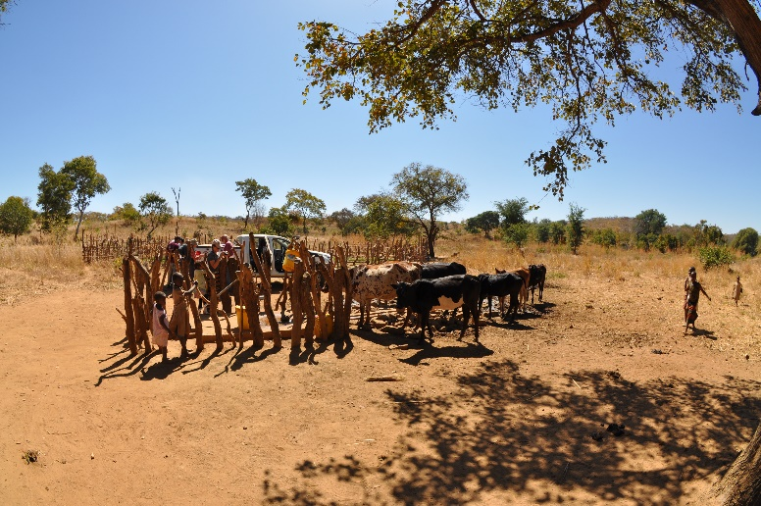
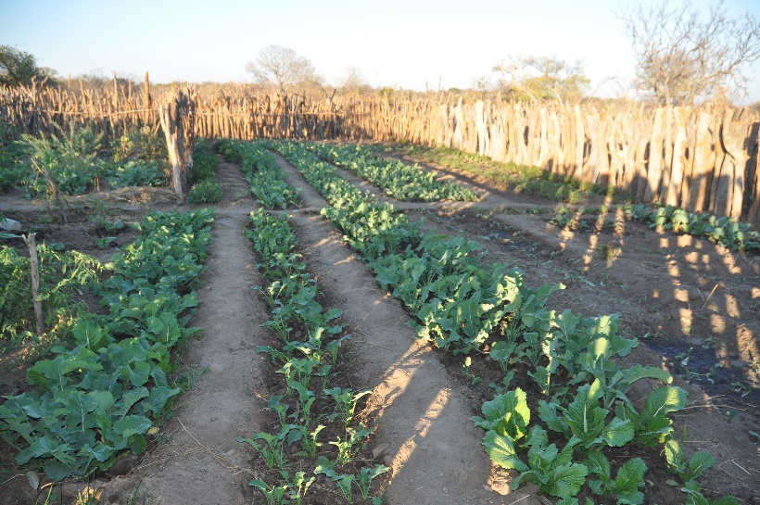
Our chapter has just recently finished its five-year commitment to a water project in the Simwatachela region of southern Zambia, Africa. Beginning in the summer of 2012, nine wells have been implemented to reach approximately 10,000 people in the chiefdom. Our focus on sustainability has been met with unequivocal enthusiasm as the local people have thrived with the newfound hope, time, and health benefits provided by easily accessible, clean drinking water.

The project also provides a chance for MSU students to gain a global perspective, apply their classroom skills to a real-world setting, and personally connect with a community of people on the other side of the world.
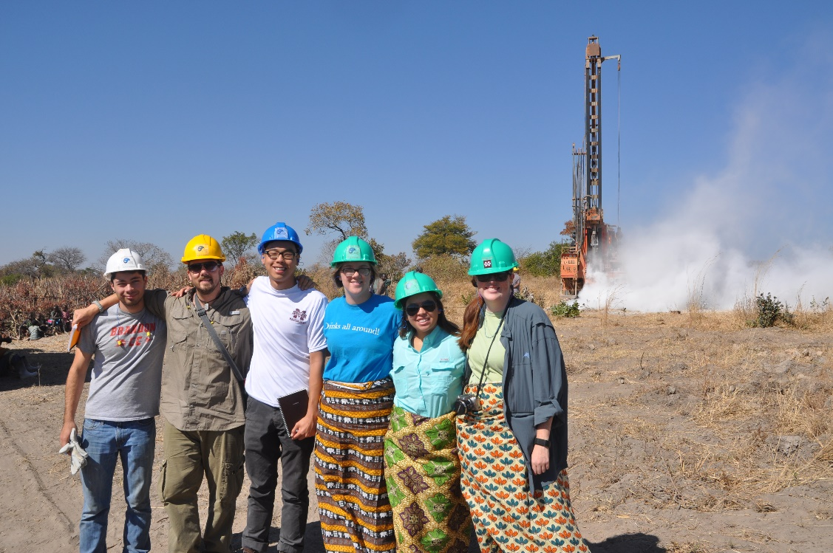
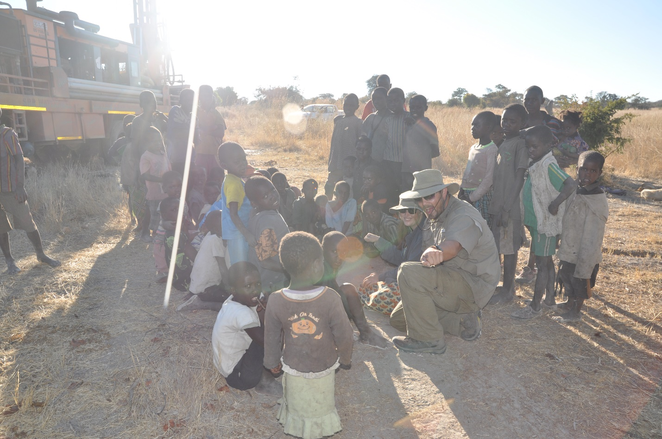

Future Project Plans

With the completion of our current project, this leaves a huge opportunity for new members to be involved in the in the project process from the beginning. This involves selecting a region, community, type of project, outlining project costs, design, marketing for the new project, etc… All of this requires a sizable team dedicated to changing lives and willing to put in a lot of work to ensure smooth chapter operations, a sustainable project design, and a successful community.

Currently, our chapter is looking at two projects. The first is a joint project with the Gulf Coast Professional EWB Chapter building bridges and a dual-purpose school/health clinic in Boca de Cuiria, Panama. The second project still has yet to be determined, but it will be sponsored by Albemarle Chemical Corporation addressing the local needs of communities in Chile. To read more about the project in Panama, please reference the project and resource packet included in your files.

Membership
If you haven't already, make sure to register for your membership at http://www.ewb-usa.org/donate/#join. You must be an officially registered member to become an officer, travel on project trips, and take advantage of other EWB-USA opportunities. Be careful to select student membership as there are no national dues. The only dues you will have to pay are our $10 chapter dues, which you will pay at meetings or through our website.

Additionally, you should register for an account at Volunteer Village at https://ewb-usa.force.com/VolunteerVillage/login. This is a platform for sharing questions and information with other members and chapters, and also is the site for international project management and administrative tasks. Help pages for this site and other EWB-USA tasks can be found here.

Resources

For more information, a project packet will be sent to each member upon paying chapter dues that provides more in-depth information about the process, past technical details, and the paperwork involved. If you are serious about joining the chapter, then we suggest joining the Volunteer Village on the EWB-USA website by registering through the join button at the top right of the page. Below are other sources for information about our chapter:

http://msstateewb.weebly.com/
(Calendar, pictures, Donation page, officer info, and chapter info)
https://www.facebook.com/msstateewb/
Follow us on twitter and Insta with the handle @msstateewb

